Kagiso Sebati
[Email address]
BELGIUM CAMPUS ITVERSITY
IAN FAASEN
ANGELITE ARENDSE
SIMEON LE ROUX
KAGISO SEBATI
BIN38121/10/2025

TABLE OF CONTENTS
1.INTRODUCTION…………………………………..
2.BUSINESS UNDERSTANDING……………………
2.1 Problem Statement……………………………….
2.2 Business Objectives……………………………….
2.3 Stakeholders……………………………………….
3.DATA MINING GOALS
3.1 Predictive Modelling for Health Key Outcomes……
3.1.1 Technical Output………………………….
3.2 Comparative Modelling & Performance Evaluation
3.2.1 Technical Output…………………………
3.3 IDENTIFICATION OF KEY FACTORS………………………………
3.3.1 Technical Output………………………………..
3.4 Measurable Outcomes………………………………
4.PROJECT TEAM ORGANISATION
5.DATA EXPLORATION & QUALITY ASSESSMENT
6.DATA PREPARATION……………………………….
6.1 Data Cleaning………………………………………….
6.2 Data Transformation………………………………….
6.3 Feature Engineering…………………………………..
6.4 Data Integration & Filtering…………………………
6.5 Feature Selection……………………………………..
6.6 Data Spliting………………………………………….
7.MODELLING………………………………………….
7.1 Selected Modelling Technique………………………
7.2 Multiple Linear Regression……………………………
7.3 Random Forest Regression………………………….
8.MODEL EVALUATION
9.DEPLOYMENT & MAINTENANCE

- INTRODUCTION
This project investigates health and demographic datasets to identify meaningful patterns in health, providing insights into population health and socio-economic factors. As Gordon mentioned there are four major sources of demographic data; population censuses, sample surveys, vital registration systems, and administrative systems (Carmichael, n.d.). By analysing the datasets gathered, this project seeks to uncover relationships between variables such as age, gender, region, and health indicators which can support data-driven decision making in healthcare and policy planning.

The project follows the CRISP-DM methodology to guide each stage of the data science process. According to a study by (Christoph Schröerab, , 2020), CRISP-DM is a de factor standard process model in data mining projects, offering a robust and repeatable approach that ensures consistency, transparency and alignment between business objectives and analytical outcomes. This ensures systematic progress through the phases of Business Understanding, Data Understanding, Data Preparation, Modeling, Evaluation, and Deployment. Tools such as R programming and Powe BI were used for visual storytelling, transforming raw health and demographic data into actionable insights that can inform public health interventions and strategic decisions.

- BUSINESS UNDERSTANDING
The primary goal is to clearly define the project from a business perspective, ensuring alignment with organisational goals and stakeholder needs before any data collection or analysis begins

  - Problem Statement
The main challenge faced by the organisation is how to effectively leverage data from various health and social indicators to generate actionable insights. This project aims to address critical public health and social challenges such as reducing child mortality, improving access to healthcare, and increasing vaccination rates. These issues are complex and multidimensional, requiring a data-driven approach to identify key contributing factors and vulnerable populations.

IAN FAASEN
ANGELITE ARENDSE
SIMEON LE ROUX
KAGISO SEBATI

  - Business Objectives
The project has multiple objectives, each driven by the need for accurate and meaningful data insights:

- Identify key drivers of specific health outcomes
- Pinpoint underserved or at-risk population based on geographical, social or economic data
- Inform strategic decision-making for resource allocation, program development and policy implementation
- Create a robust data foundation that can be used for ongoing monitoring and evaluation of public health initiatives

  - Stakeholders
This project involves several stakeholders who have a vested interest in addressing the public health issues identified, they include:

• Government health officials: They need the data to inform policy and monitor program effectiveness
• Non-profit program managers: They require findings to optimise the delivery of aid and services.
• Field workers and frontline staff: They need easy-to-understand information to guide their day-to-day operations and outreach efforts.
• Data analysts/scientists: The project team responsible for the executing the technical components of the project
• Donors/funding organisations: They need to see evidence of impact to justify their investment

Stakeholder engagement involves interviews and workshops to determine:

• Specific questions for example: “Which region have the lowest immunization rates”.
• What their desired outputs would be
• What timeline do they desire and what is their budget
• How do they want their data to be used, with other words, data privacy and the security concerns

- DATA MINING GOALS
While many data analysis tasks follow a traditional, hypotheses approach, modern data mining often follows data-driven strategy that encourages algorithms to detect useful patterns, trends, and relationships within large datasets. According to (Jackson, 2002) data mining approaches can be broadly categorized into model-building methods, such as regression, cluster analysis, as well as tree-based classification that summarizes and predicts data, and pattern discovery methods, which identify previously hidden structures. Using both approaches help us create understandable models and discover new findings that might not be obvious with traditional analysis.

This project translates the business problem, improving public health outcomes through data-driven findings into measurable technical data mining goals. These goals define what must be achieved through modelling and analysis to support evidence-based policy and decision-making.

  - Predictive Modelling for Health Key Outcomes
The first goal is developing predictive models capable of estimating Skilled Birth Attendance (SBA) rates based on a variety of demographic and health indicators. Using Multiple Linear Regression (MLR) and Random Forest Regression (RF), the models aim to forecast the likelihood of skilled in health personnel attending births in different regions.

    - Technical Output
- Predictive models trained and validated using cross-validation (RMSE, R2)
- Model stored as an R Markdown output and integrated into Power BI for interactive visualizations.

  - Comparative Modelling and Performance Evaluation
The second goal is comparing the performance of linear and non-linear methods to determine which best fits the data and business needs. This comparison enables the selection of the most robust and generalizable model for deployment.

3.2.2 Technical Output
- Comparative results (RMSE, MAE, R2) across (MLR) and (RF) models
- Diagnostic and residual plots for model validation
- Variable importance ranking to highlight top predictive factors

  - Identification of Key Contributing Factors
The third goal is identifying and ranking the most influential predictors contributing to maternal and new born health outcomes. This supports the business goal of pin pointing at risk populations and optimizing healthcare interventions.

    - Technical Output:
- Ranked feature importance report highlighting top 10 predictors
- Visualizations through Power BI dashboards for stakeholder interpretation

  - Measurable Outcomes
To ensure actionable impact, the project defines success in terms of measurable improvements and decision-support outcomes:
- Achieve at least a 15% reduction in model RMSE compared to baseline
- Enable data-driven prioritisation of regions with low SBA rates
- Deliver a Power BI dashboard for ongoing monitoring and stakeholder use

- PROJECT TEAM ORGANISATION
Although our team worked collaboratively on all stages of the project, specific roles were assigned to ensure clear direction and accountability. Every member participated in discussions, analysis, and decision making, contributing to both technical and documentation tasks. This collaborative approach ensured consistency and quality across all deliverables.

    - Project Lead & Coordinator: Simeon Le Roux oversaw project planning, progress tracking, and ensured alignment with CRISP-DM methodology.
    - Data Preparation Lead: Ian Faasen an Angelite Arendse led in cleaning the data, ensuring quality and completeness.
    - Modelling & Analysis Leads: Ian Faasen and Kagiso Sebati focused on applying data mining techniques, building models, and interpreting analytical results.
    - Visualization and Dashboard Developers: Ian Faasen and Simeon Le Roux designed Power BI dashboards and visual story telling elements for data presentation.
    - Documentation and Review Lead: Angelite Arendse and Kagiso Sebati compiled written sections, formatted the report, and ensured that findings and results were clearly communicated.
Despite the roles assigned, all members collaborated in each phase of the project, providing feedback, sharing insights, and supporting one another throughout the process.

- DATA EXPLORARTION AND QUALITY ASSESSMENT
The datasets used in this report were combined to form one master dataset; Master_Dataset_U5MR_Class.csv contains 17 variables capturing diverse health and demographic indicators related to maternal and child wellbeing. Key features include Under-Five Mortality Rate (U5MR), Maternal Mortality Ratio, Pregnancy-related Mortality Rate, General Mortality Rate, and various immunisation and breastfeeding indicators such as BSG, DPT3,Measles, Exclusive breastfeeding, and early breastfeeding. The target variable; U5MR_Status, classifies mortality levels into categorical outcomes such as Low, Medium, or High, enabling supervised machine learning analysis.

During the initial exploration, data types were verified to ensure consistency across numerical and categorical variables. Preliminary assessment revealed that while most numeric features were well-structured, some variables (Maternal_Mortality_Ratio , Pregnancy_Related_Mortality_Rate, General_Fertility_Rate) contained a notable proportion of zero or missing values, possibly reflecting incomplete data entries or unreported metrics. Descriptive statistics were computed to summarize central tendencies and dispersions, revealing high variability among fertility and mortality measures across survey years.

The dataset spans multiple survey years, supporting temporary trend analysis and detecting patterns over time. Visual inspections using histograms, correlation plots were used to provide findings into variable distributions and potential relationships between key indicators such as skilled birth attendance, antenatal care, and under-five mortality. These findings informed subsequent data cleaning and preparation steps, including treating missing values, scaling numerical predictors, and encoding categorical variables for model readiness.

- DATA PREPARATION
The data preparation stage focused on transforming and refining the dataset to ensure it was suitable for modelling. This process was essential to improve data quality, handle inconsistencies, and enhance model performance.

  - Data Cleaning
The raw datasets contained missing and inconsistent values, especially in indicators such as; Maternal_Mortility_Ratio, Exclusive Breastfeding, and GDP per capita. These were addressed using appropriate strategies:
- Numerical variables: replaced missing values with the median
- Categorical variables: imputed using the mode (most frequent value)
- Duplicates and outliers: duplicate rows were removed, and outliers were detected using the interquartile range (IQR) method. Extreme outliers that could distort regression models were capped within reasonable limits.

  - Data Transformation
To improve comparability between variables measured on different scales, normalization and standardization were applied:
- Z-score standardization was used for features such as fertility rate, health expenditure, and immunisation coverage.
- Log transformation was applied to highly skewed variables like GDP per capita and Population to reduce variance and make distributions more symmetric.

  - Feature Engineering
Several derived features were created to improve model predictive power:
- Lagged indicators: value_lag1 variable was introduced to capture temporal dependencies
- Aggregated rates: a composite index was created by averaging related health coverage indicators; Measles, DPT3, BCG to represent overall immunisation performance
- Categorical encoding: The U5MR_Status variable was encoded numerically (Low =0, Medium =1, High = 2) to support model training.

  - Data Integration and Filtering
Since the master dataset combined multiple survey sources, the data was balanced by aligning year, region, and indicator definitions. Only records with complete information for the selected indicators were retained to ensure consistency during cross-validation.

  - Feature Selection
Correlation and variable importance analysis were conducted to identify the strongest predictors of (U5MR). Features with very low variance or high correlation (correlation > 0.9) were removed to prevent redundancy, the final predictors include:
- Maternal Mortality Ratio
- Skilled Birth Attendance
- Fertility Rate
- Antenatal Care Coverage
- Immunisation Indicators (BCG, Measles, DPT3)
- GDP per Capita
- Health expenditure per Capita

  - Data Splitting
Before modelling, the cleaned dataset was partitioned into training (80%) and testing (20%) sets. The training data was used to develop and tune the models using 10-fold cross-validation, ensuring that performance metrics were generalisable and not overfitted to a single dataset split.

- MODELLING

  - Selected Modelling Technique
The Regression Analysis modelling approach was selected, which is designed to predict continuous public health indicators across multiple datasets. Since the target variable represents continuous percentages, regression models are the most suitable.

  - Multiple Linear Regression (MLR)

This technique was chosen as the primary model because the dataset demonstrates strong linear relationships between features and the target variable, confirmed using Pearson’s correlation. MLR provides interpretable coefficients, allowing policy makers to understand how each factor (antenatal care, delivery place) contributes to skilled birth attendance.
  - Random Forest Regression (RF)
RF was selected as the secondary model due to its robustness in capturing non-linear relationships and handling high correlation. This non-parametric technique complements MLR by improving predictive accuracy where linearity is weak.

- MODEL EVALUATION
Both models; (MLR) and (RF) were evaluated using 10-fold cross validation to ensure stable and unbiased results. Random Forest Regression achieved a lower RMSE and a higher R2 than Multiple Linear Regression, confirming better predictive performance and robustness.

Residual plots for Multiple Linear Regression indicated some non-linearity and non-variance, while Random Forest Regression were more evenly distributed, suggesting a stronger model fit. Variable importance analysis revealed that standardized indicator value (value_z) and lagged values (value_lag1) were the dominant predictors, while facility delivery and antenatal care indicators contributed secondary importance.

Overall, the Random Forest Regression model met the project’ success criteria for accuracy and robustness, while Multiple Linear Regression provided transparency and interpretability. The combination of these models offers a comprehensive understanding of the factors influencing under-five mortality trends.

- DEPLOYMENT AND MAINTENANCE
The model outputs and evaluation metrics were prepared for visualizations using Power BI to support stakeholder interaction and decision-making. Model deployment will involve integrating the Random Forest predictions into a dashboard, enabling users to explore trends in skilled birth attendance by region, year, or predictor variable.

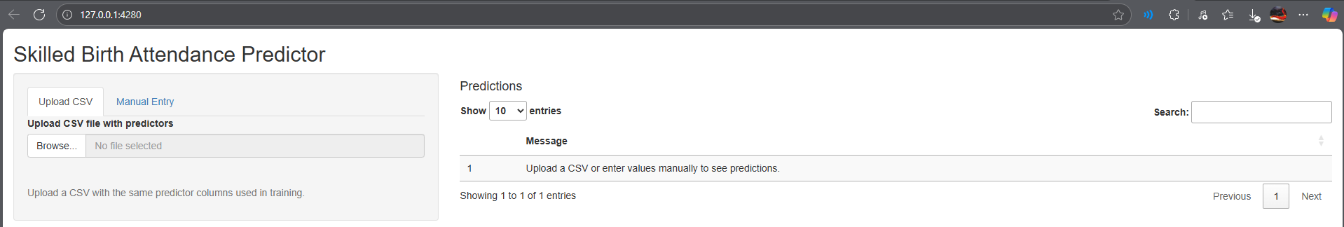
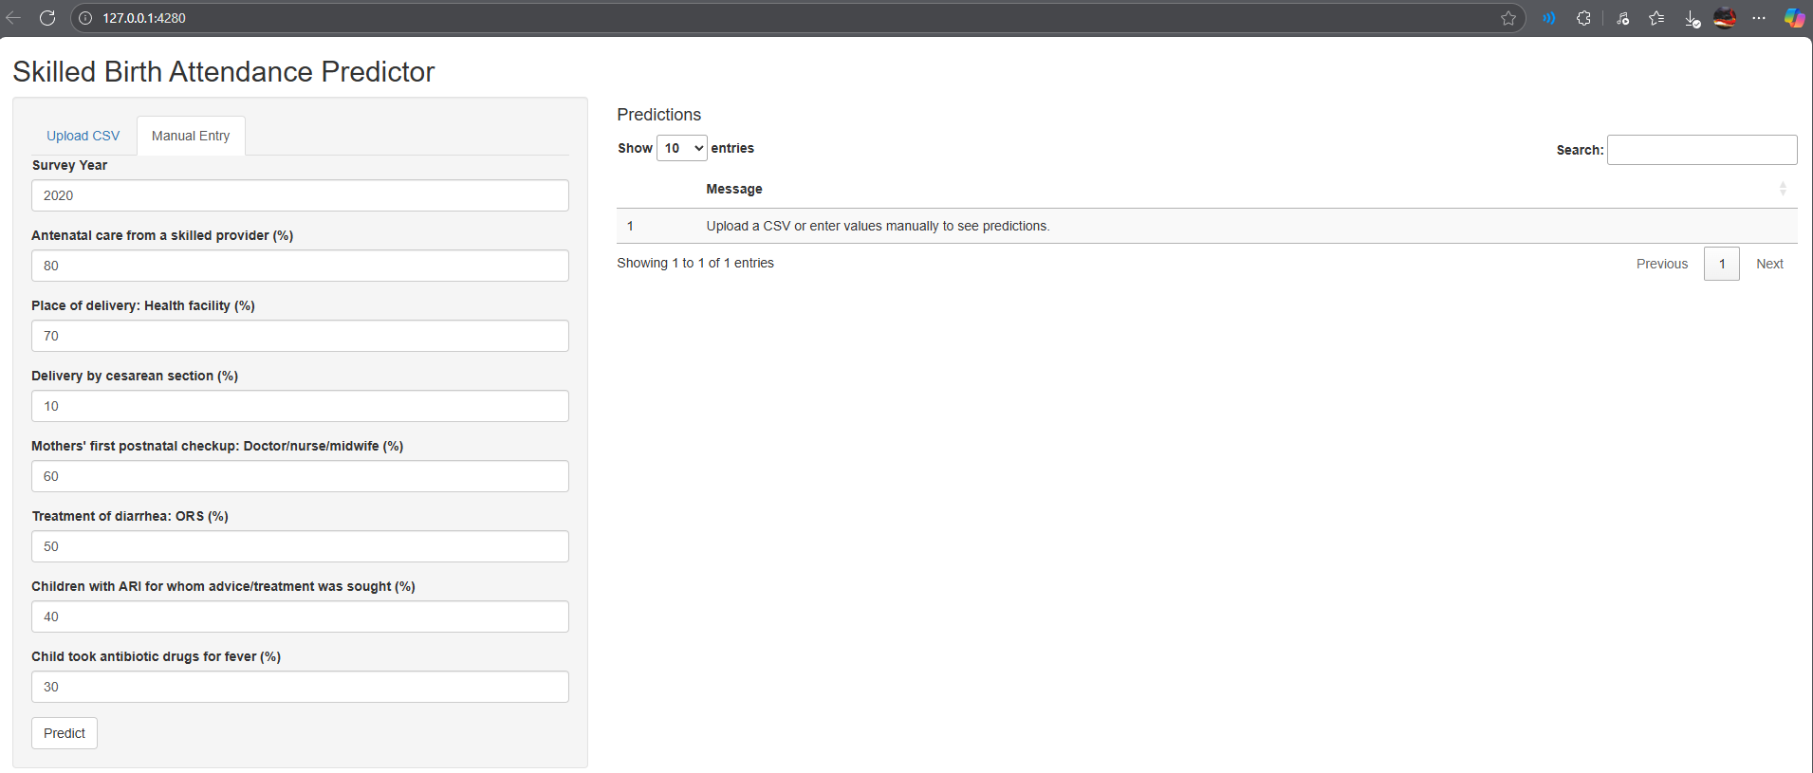
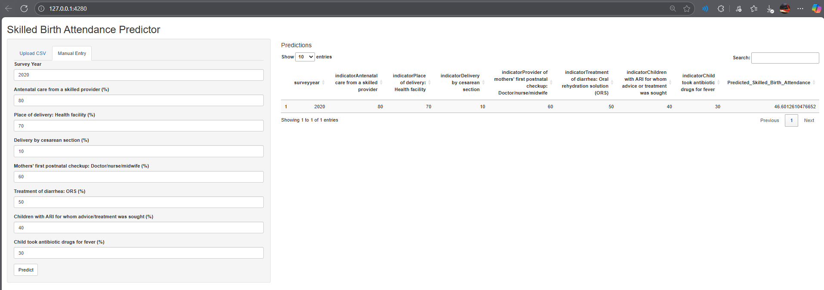

The model is deployed using the Shinyapps framework. It includes a fully functional dashboard that allows users to either upload a CSV of data or then predicting the skilled birth attendance with this functionality. Or users can manually enter the indicator fields and predict an outcome manually.

References
Carmichael, G. A., n.d. Fundamentals of Demographic Analysis: Concepts, Measures and Methods. Volume 38 ed. Canberra: s.n.
Christoph Schröerab, , 2020. A Systematic Literature Review, Oldenburg, Germany: Elsevier B.V.
Jackson, J., 2002. Data Mining; A Conceptual Overview . In: Communications of the Association for Information Systems. s.l.:s.n.

